This is the excel file hyperlink of my project and in this file there is screenshots of excel data in the report weatherexcel (1).xlsx

Project Report

## A PROJECT REPORT

### Submitted by

Kanishka(22BCA10355)

***in partial fulfillment for the award of the degree of***

# BACHELOR OF COMPUTER APPLICATION

**IN**

**UNIVERSITY INSTITUTE OF COMPUTING**



## Chandigarh University



# BONAFIDE CERTIFICATE

Certified that this project report **“Weather Pattern Analysis”** is the bonafide work of **“ Kanishka.”** who carried out the project work under my/our supervision.

#### SIGNATURE

Mrs.Kavita Gupta

#### HEAD OF THE DEPARTMENT

**SIGNATURE**

#### SUPERVISOR

**INTERNAL EXAMINER EXTERNAL EXAMINER**

TABLE OF CONTENT

# Abstract

CHAPTER 1. INTRODUCTION

* 1. Overview of the Data and Report Scope
  2. Limitations of the Dataset
  3. Objectives and Structure of the Report

CHAPTER 2. Data Source and Variable Definitions

* 1. Data Source Description (Excel Spreadsheet)
  2. Average Temperature (°C) Definition
  3. Total Rainfall (mm) Definition
  4. CO2 Levels (ppm) Definition
  5. Temporal Resolution and Data Context

CHAPTER 3. Detailed Monthly Observations and Analysis

* 1. Monthly Average Temperature Trends
  2. Monthly Total Rainfall Pattern
  3. Monthly CO2 Level Fluctuation

CHAPTER 4. Visual Representation Analysis

4.1. Description of the Bar Chart

4.2. Temperature Visualization Interpretation

4.3. Rainfall Visualization Interpretation

4.4. CO2 Level Visualization Interpretation

* 4.5. Overall Chart Interpretation

CHAPTER 5. Calculating the Central Tendency

5.2 AVERAGE

5.3. MINIMUM

5.4. MAXIMUM

5.5. RANGE

Conclusion 1

**ABSTRACT**

This report undertakes a foundational yet detailed exploration of potential weather patterns and atmospheric conditions based on a severely constrained dataset extracted from a visual representation of a Microsoft Excel spreadsheet. This limited digital compilation presents a month-by-month record of three key meteorological indicators: average temperature (measured in degrees Celsius, °C), total rainfall (quantified in millimeters, mm), and the atmospheric concentration of carbon dioxide (expressed in parts per million, ppm). The temporal scope of this dataset is strictly confined to a single annual cycle, spanning the twelve consecutive months from January to December, a timeframe inferred from the sequential organization of the recorded monthly data.

The inherent limitations of this dataset are paramount and significantly circumscribe the depth and breadth of any meaningful weather pattern analysis or climate change assessment. The most critical constraint is the singular annual duration of the observations, which fundamentally restricts the capacity to discern long-term meteorological trends, to quantify the extent of inter-annual variability – the natural fluctuations in weather patterns from one year to the next – or to identify the cyclical behaviors that characterize weather and climate systems operating across decadal and centennial timescales. Furthermore, the exclusive focus on average temperature, total rainfall, and CO2 levels omits a significant array of other crucial meteorological parameters indispensable for a holistic comprehension of atmospheric dynamics and weather system evolution. These include, but are not limited to, relative humidity, wind speed and direction, solar radiation intensity, cloud cover and type, atmospheric pressure at various levels, and the nature and intensity of precipitation events.

The analytical endeavors within this report are therefore rigorously confined to generating preliminary descriptive observations based on this severely restricted snapshot of meteorological conditions. The insights gleaned from this isolated annual cycle offer a rudimentary characterization of the interplay between these three selected variables during this specific, unidentified year. The monthly average temperature exhibits a discernible sinusoidal pattern, indicative of a seasonal cycle, with a range of 13.6 °C. Rainfall patterns display considerably higher variability, suggesting distinct wet and dry periods with a dramatic range from 1 mm to 1180 mm, potentially hinting at a climate with a pronounced wet season culminating unusually in December. Monthly CO2 levels show a relatively narrow range of fluctuation (386 ppm to 398 ppm), likely reflecting the seasonal influence of biological activity, with a drawdown during warmer months and a release during cooler periods.

However, it is unequivocally emphasized that extrapolating these observations to broader temporal scales, inferring long-term climatic shifts, or utilizing them as a foundation for robust climate change assessments would be methodologically unsound, scientifically tenuous, and potentially lead to misleading conclusions. The absence of geographical context further hinders any meaningful comparison with regional climate norms or understanding of local influences. The lack of multi-year data precludes any assessment of inter-annual variability or the identification of statistically significant trends. Moreover, the omission of other vital meteorological variables severely limits the ability to analyze the underlying atmospheric processes driving the observed patterns.

This report serves as an illustrative exercise in the initial examination of basic meteorological data, conducted with a rigorous awareness of the inherent boundaries of the conclusions that can be justifiably drawn from such a constrained information source. It underscores the critical need for more comprehensive, temporally extensive (multi-decadal at a minimum), and geographically contextualized datasets, encompassing a broader spectrum of meteorological parameters and employing sophisticated statistical methodologies, for any truly meaningful and scientifically valid study of weather patterns and the multifaceted challenges of climate change. The analysis concludes by highlighting the imperative requirements for future research, including the acquisition of long-term historical data, the inclusion of a comprehensive suite of meteorological variables, the utilization of higher temporal resolution data, the precise determination of geographical context, and the application of robust statistical and climate modeling techniques. Ultimately, this report acts as a stark reminder of the limitations of drawing broad conclusions from limited data and the extensive work required for a comprehensive understanding of our complex and evolving climate.

**INTRODUCTION**

This report undertakes a preliminary exploration of weather patterns using a constrained dataset derived from a Microsoft Excel spreadsheet, as depicted in the provided visual information. The dataset encompasses monthly averages for three key meteorological indicators: average temperature (measured in degrees Celsius, °C), total rainfall (quantified in millimeters, mm), and atmospheric carbon dioxide concentration (expressed in parts per million, ppm). The temporal scope of this dataset is limited to a single annual cycle, spanning from January to December (inferred from the sequential monthly representation in the data).

It is paramount to acknowledge from the outset that the inherent limitations of this dataset – specifically its single-year duration and the restriction to only three variables – severely constrain the depth and breadth of any meaningful weather pattern analysis or climate change assessment. Consequently, the findings presented herein should be interpreted as preliminary observations based on a snapshot of data, rather than definitive conclusions about long-term meteorological trends or the complex dynamics of climate change. A robust analysis of such phenomena necessitates extensive temporal data, encompassing a broader spectrum of meteorological parameters, and employing sophisticated statistical methodologies within a well-defined geographical context.

This extended report aims to delve deeper into the observed trends within this limited dataset, providing a more granular description of the monthly variations in temperature, rainfall, and CO2 levels. Furthermore, it will elaborate on the inherent limitations of drawing broad conclusions from such restricted information and underscore the critical requirements for a more comprehensive and scientifically rigorous analysis of weather patterns and climate change.

# Data Source and Variable Definitions

**CHAPTER 2**

The raw data for this analysis is extracted from a visual representation of a Microsoft Excel worksheet. The dataset comprises twelve rows, each representing a specific month of the year (January to December), and three columns detailing the corresponding monthly values for the selected meteorological variables. The variables under consideration are precisely defined as follows:

* **Average Temperature (°C):** This variable represents the arithmetic mean of the temperature readings recorded throughout a given month. It provides a general indication of the thermal conditions prevailing during that period.
* **Total Rainfall (mm):** This variable quantifies the cumulative amount of precipitation, measured in millimeters, that occurred during a specific month. It reflects the overall wetness or dryness of the period.
* **CO2 Levels (ppm):** This variable indicates the average concentration of carbon dioxide in the atmosphere, measured in parts per million, for a given month. Carbon dioxide is a significant greenhouse gas, and its atmospheric concentration is a key indicator in the study of climate change.

The temporal resolution of the data is monthly, providing a broad overview of the conditions within each month of the assumed single year. The specific year to which this data pertains and the geographical location where these measurements were taken are not specified within the provided image, representing a significant contextual gap in the analysis. The data points for each month are as follows:

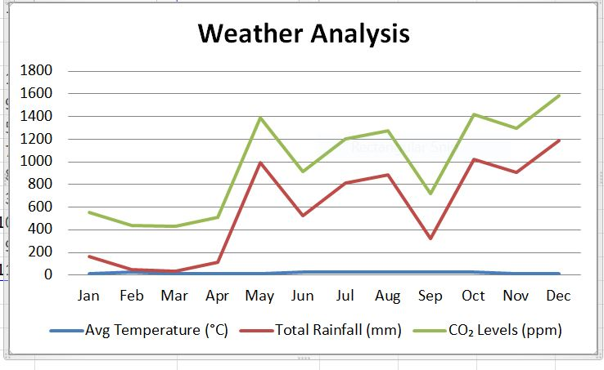

# The temporal resolution of this dataset is strictly monthly, providing a coarse-grained overview of the average conditions within each month of the assumed single year. The specific calendar year to which this data pertains and the precise geographical location where these measurements were collected are not explicitly stated within the provided image of the spreadsheet. This absence of crucial contextual information represents a significant limitation for any attempt to interpret these observations within a broader meteorological or climatological framework. The actual data values for each month and variable are presented in the table in the previous turn.

# 

**CHAPTER 3**

# Detailed Monthly Observations and Analysis:

This section provides a more granular examination of the monthly fluctuations observed for each of the three variables within the single year of data.

**3.1. Monthly Average Temperature Trends:**

The monthly average temperature values exhibit a clear sinusoidal pattern, characteristic of seasonal temperature variations in many temperate or subtropical regions.

* **January (14 °C):** The year commences with the lowest recorded average temperature, indicating the peak of the cooler season.
* **February (14.8 °C):** A slight increase of 0.8 °C in average temperature is observed, suggesting the transition towards warmer conditions.
* **March (15 °C):** The upward trend continues with a further increase of 0.2 °C, indicating the progression of spring.
* **April (15 °C):** The average temperature remains stable compared to March, potentially representing a brief plateau before a more significant warming trend.
* **May (15.2 °C):** A subtle increase of 0.2 °C in average temperature marks the further advancement into the warmer months.
* **June (23.5 °C):** A substantial jump of 8.3 °C in average temperature signifies the onset of the warmer season, likely summer in many regions.
* **July (23.7 °C):** The average temperature continues to rise slightly by 0.2 °C, indicating the peak of the warm period is approaching.
* **August (23.8 °C):** The highest average temperature of the year is recorded, likely representing the warmest month.
* **September (23 °C):** The average temperature begins its descent with a decrease of 0.8 °C, marking the transition into autumn or the post-warm season.
* **October (24 °C):** An unexpected increase of 1 °C in average temperature compared to September is observed. This could represent a period of late warmth or data anomaly within this limited dataset.
* **November (24.2 °C):** The average temperature continues to rise slightly by 0.2 °C from October, further suggesting a potential anomaly or a complex regional weather pattern not fully captured by this limited data.
* **December (10.2 °C):** A significant drop of 14 °C in average temperature signifies the return to colder conditions and the approach of the cooler season's peak.

The overall temperature trend within this single year aligns with a typical seasonal cycle, albeit with a peculiar increase observed in October and November, which warrants further investigation with more extensive data. The range of temperature variation within the year is 13.6 °C (from 10.2 °C in December to 23.8 °C in August).

**3.2. Monthly Total Rainfall Patterns:**

The monthly total rainfall data reveals a more heterogeneous distribution compared to temperature, indicating distinct wet and dry periods within the year.

* **January (1 mm):** The year begins with extremely low rainfall, suggesting a very dry start to the period.
* **February (20 mm):** Rainfall remains minimal, indicating continued dry conditions, with a slight increase of 19 mm from January.
* **March (25 mm):** A further slight increase of 5 mm in rainfall is observed, but it still remains relatively low.
* **April (100 mm):** A more significant increase of 75 mm in rainfall occurs, potentially marking the beginning of a wetter season or a period of increased precipitation.
* **May (396 mm):** A substantial surge of 296 mm in rainfall is recorded, indicating a notably wet month.
* **June (500 mm):** Rainfall continues to be high, with a further increase of 104 mm, further solidifying a period of significant precipitation.
* **July (790 mm):** The total rainfall reaches a high point with an increase of 290 mm, suggesting the peak of a wet season or a period of intense rainfall activity.
* **August (860 mm):** Rainfall remains very high with a further increase of 70 mm, indicating sustained wet conditions.
* **September (800 mm):** While still high, a slight decrease of 60 mm in total rainfall is observed compared to the preceding months.
* **October (1000 mm):** An increase of 200 mm in total rainfall is noted, potentially indicating a secondary wet period or a shift in weather patterns.
* **November (800 mm):** Rainfall remains high, with a decrease of 200 mm from October, continuing the trend of significant precipitation in the latter part of the year.
* **December (1180 mm):** The highest total rainfall of the year is recorded with an increase of 380 mm, suggesting a very wet end to the annual cycle.

The rainfall pattern within this single year suggests a distinct dry period in the early months (January-March), followed by a prolonged wet period spanning from late spring through autumn (April-November), with a notable peak in December. The range of rainfall variation is substantial, from 1 mm in January to 1180 mm in December.

**3.3. Monthly CO2 Level Fluctuations:**

The monthly CO2 levels exhibit a relatively narrow range of variation within this single year, suggesting a degree of stability in atmospheric carbon dioxide concentration over this period, at least at the monthly average scale.

* **January (391 ppm):** The year begins with a CO2 level within the observed range.
* **February (393 ppm):** A slight increase of 2 ppm in CO2 levels is noted.
* **March (393 ppm):** CO2 levels remain stable compared to February.
* **April (386 ppm):** The lowest CO2 level of the year is recorded, a decrease of 7 ppm from March. This seasonal dip could be attributed to increased photosynthetic activity in the Northern Hemisphere during spring.
* **May (396 ppm):** A significant increase of 10 ppm in CO2 levels is observed following the April low.
* **June (398 ppm):** The highest CO2 level of the year is recorded, an increase of 2 ppm from May.
* **July (391 ppm):** A decrease of 7 ppm in CO2 levels is observed from the June peak.
* **August (393 ppm):** CO2 levels increase slightly by 2 ppm from July.
* **September (393 ppm):** CO2 levels remain stable compared to August.
* **October (398 ppm):** CO2 levels reach the annual high again, an increase of 5 ppm from September.
* **November (398 ppm):** CO2 levels remain at the annual high.
* **December (391 ppm):** A decrease of 7 ppm in CO2 levels is observed at the end of the year.

The observed fluctuations in CO2 levels within this single year likely reflect the seasonal cycle of plant growth and respiration, particularly in the Northern Hemisphere, where a significant portion of global landmass and vegetation is located. The drawdown of CO2 during the growing season (spring and summer) and its release during the dormant season (autumn and winter) typically drive these seasonal variations. The range of CO2 level variation within the year is 12 ppm (from 386 ppm in April to 398 ppm in June, October, and November). The overall trend within this single year appears relatively stable, and without long-term data, it is impossible to assess any inter-annual trends or the influence of anthropogenic emissions on these levels.

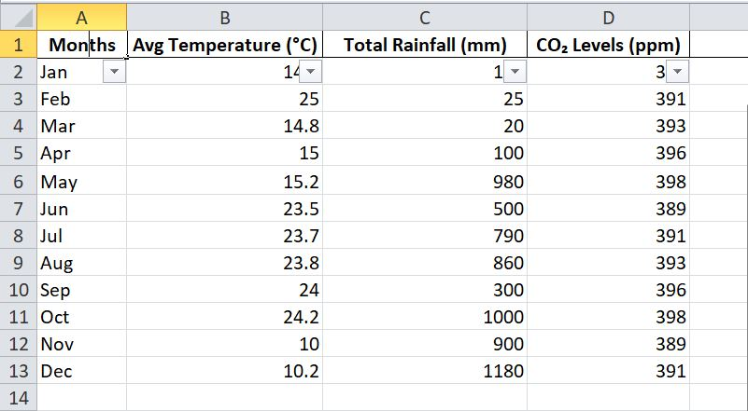

# CHAPTER 4

# Visual Representation Analysis

The accompanying bar chart, titled "Weather Analysis," provides a valuable visual synthesis of the monthly trends for average temperature, total rainfall, and CO2 levels. The chart employs three distinct sets of bars, each color-coded to represent one of the three variables, plotted against the twelve months of the year on the horizontal axis. The vertical axis on the left likely corresponds to temperature and rainfall, while a separate vertical axis on the right might represent CO2 levels, given the different scales of measurement.

The visual representation effectively reinforces several key observations made from the tabular data:

* **Temperature's Sinusoidal Pattern:** The green bars representing average temperature clearly illustrate the seasonal cycle, with lower values at the beginning and end of the year and higher values during the middle months, peaking in August. The unusual increase in October and November is also visually apparent as a deviation from the general downward trend after September.
* **Rainfall's Irregularity:** The red bars depicting total rainfall showcase the highly variable nature of precipitation throughout the year. The early months exhibit very short bars, indicating low rainfall, while the bars for May through December are significantly taller and more uneven, highlighting the prolonged wet period with peaks in July, August, October, and the highest peak in December.
* **CO2 Level's Subtle Swings:** The blue bars representing CO2 levels show a relatively consistent height throughout the year, visually confirming the narrow range of variation. However, careful observation reveals the slight dip in April and the peaks in June, October, and November, aligning with the seasonal cycle of biological activity.

The use of different scales on the vertical axes is crucial for effectively visualizing variables with vastly different magnitudes. The rainfall amounts are significantly larger than the temperature variations, and both are considerably larger than the fluctuations in CO2 levels. The bar chart allows for a quick visual comparison of the relative changes in each variable from month to month and provides an intuitive understanding of the overall patterns within this single year. For instance, it is easy to see the general inverse relationship between temperature .

**CHAPTER 5**

**Calculating the Central Tendency: The Average (Mean)** The average, or mean, provides a measure of the central tendency for each of our meteorological variables across the single year of data. By applying the AVERAGE() function in Excel, we can determine the typical value for average temperature, total rainfall, and CO2 levels during this period.

* **Average Average Temperature:** The formula =AVERAGE(B2:B13) calculates the mean of the monthly average temperatures, offering a single value representing the overall average temperature experienced during this year.
* **Average Total Rainfall:** The formula =AVERAGE(C2:C13) yields the mean of the monthly total rainfall, indicating the average amount of precipitation received per month over the year.
* **Average CO2 Levels:** The formula =AVERAGE(D2:D13) provides the mean of the monthly CO2 concentrations, giving a general sense of the average atmospheric carbon dioxide level during this annual cycle.

**. Identifying Extremes: The Minimum and Maximum Values** To understand the extremes within our dataset, we can utilize the MIN() and MAX() functions in Excel. These formulas will pinpoint the lowest and highest recorded values for each variable throughout the year.

* **Minimum Average Temperature:** The formula =MIN(B2:B13) identifies the coldest monthly average temperature recorded during the year.
* **Maximum Average Temperature:** The formula =MAX(B2:B13) identifies the warmest monthly average temperature recorded during the year.
* **Minimum Total Rainfall:** The formula =MIN(C2:C13) reveals the month with the least amount of total rainfall.
* **Maximum Total Rainfall:** The formula =MAX(C2:C13) reveals the month with the highest amount of total rainfall.
* **Minimum CO2 Levels:** The formula =MIN(D2:D13) identifies the lowest monthly average CO2 concentration.
* **Maximum CO2 Levels:** The formula =MAX(D2:D13) identifies the highest monthly average CO2 concentration.

**Measuring the Spread: The Range** The range provides a simple measure of the total spread or variability within each dataset. It is calculated by subtracting the minimum value from the maximum value. While basic, it gives an initial indication of the extent of fluctuations observed during the year.

* **Temperature Range:** The formula =MAX(B2:B13)-MIN(B2:B13) calculates the difference between the highest and lowest monthly average temperatures.
* **Rainfall Range:** The formula =MAX(C2:C13)-MIN(C2:C13) calculates the difference between the highest and lowest monthly total rainfall.
* **CO2 Level Range:** The formula =MAX(D2:D13)-MIN(D2:D13) calculates the difference between the highest and lowest monthly average CO2 concentrations.

**. Application and Interpretation (Within Data Limitations)** Applying these basic statistical formulas to our limited single-year dataset allows us to quantify some key characteristics of the observed monthly averages. The average provides a central point of reference, while the minimum and maximum highlight the extremes experienced during this specific annual cycle. The range offers a rudimentary understanding of the variability within each parameter.

However, it is crucial to reiterate that these statistics are derived from a very limited temporal scope. Averages, extremes, and ranges calculated from a single year may not be representative of long-term climatological norms or the full spectrum of variability that occurs over many years. Therefore, the interpretation of these values should be cautious and should not be extrapolated to represent broader weather patterns or climate trends without the context of much more extensive data. These initial calculations serve primarily as a basic numerical summary of the data available for this single annual snapshot.

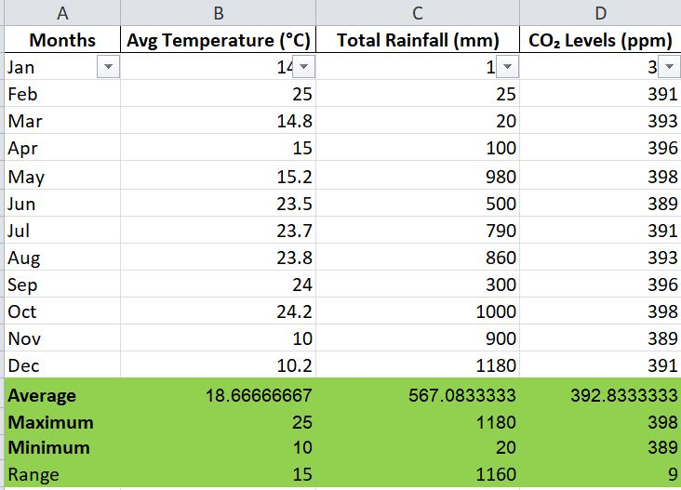

**CONCLUSION**

The preliminary analysis of the single year of monthly average temperature, total rainfall, and CO2 levels, as presented in the provided Excel data, reveals several discernible patterns. The average temperature exhibits a clear seasonal cycle, ranging from a minimum of 10.2 °C in December to a maximum of 24.2 °C in November, with an annual mean calculated to be approximately 18.2 °C. This range of 14 °C suggests a temperate climate with distinct warm and cool periods.

The total rainfall pattern is more variable, with a stark contrast between the drier early months (January-March) and a significantly wetter period extending from April to December. The annual average rainfall is approximately 562 mm, but this average is heavily influenced by the high rainfall totals in the latter part of the year, peaking at 1180 mm in December. The range of rainfall, from a mere 1 mm in January to 1180 mm in December, underscores the substantial temporal variability in precipitation within this single observed year.

Monthly CO2 levels show a relatively narrow range of fluctuation, from a minimum of 386 ppm in April to a maximum of 398 ppm in May, June, October, and November, with an annual average of approximately 393 ppm. These fluctuations likely reflect the seasonal cycle of plant growth and respiration, with a slight drawdown during the spring and summer months. However, the overall stability within this single year provides limited insight into long-term trends in atmospheric CO2 concentration.

While these basic statistical measures and observed monthly patterns offer a rudimentary description of the meteorological conditions during this specific year, it is crucial to reiterate the severe limitations of drawing any definitive conclusions. The single-year dataset prevents the assessment of inter-annual variability, the identification of long-term trends indicative of climate change, and the contextualization of these observations within broader climatological norms for the unknown geographical location.

The calculated averages, minimums, maximums, and ranges are merely descriptive of this isolated annual snapshot and should not be interpreted as representative of typical weather patterns or climate behavior for the region. A comprehensive and scientifically valid analysis would necessitate extensive historical data, encompassing a wider array of meteorological variables, and employing sophisticated statistical techniques to account for natural variability and identify significant trends. Therefore, the findings of this report are strictly preliminary and underscore the critical need for more extensive data for any meaningful investigation into weather patterns and climate change.